Stage 5 – Abu Bakr al-Baghdadi is dead.
COURSE DESIGNER: John Royer / Outdoor Dynamics
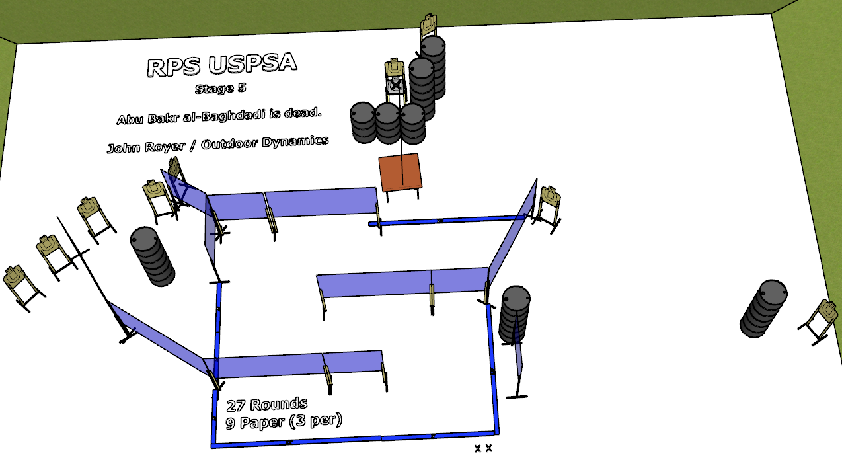

Written Stage Briefing:
Stage 5 – Abu Bakr al-Baghdadi is dead. - is a 27 round, 135 point, Comstock course. There are 9 cardboard targets. The best 3 hits per cardboard target will be scored.

The Exorcist target is activated by pulling on the pull rope until the target is visible. The target is NOT Visible at rest.

Start position is both feet on the Shooting Sports Innovations Xs.
Handgun loaded and holstered, wrists below belt.
PCC loaded, stock on belt.

NOTE: Each shooter will be given ONE chance to activate The Exorcist during the 4 minute walk through.

Per 9.9.3 - Activated appearing scoring targets will always incur failure to shoot at and miss penalties if a competitor does not activate the target movement either before or with the last shot fired in a course of fire.

Setup Notes:
9 Single Wall Stands
6 Double Wall Stands
1 Triple Wall Stand
6 Full Walls – 6 Half Walls
8 Target stands / 16 target sticks
1 Exorcist Target + sticks and pull rope
1 Starting Xs
14+ barrels


